Disability support work is more than
you think
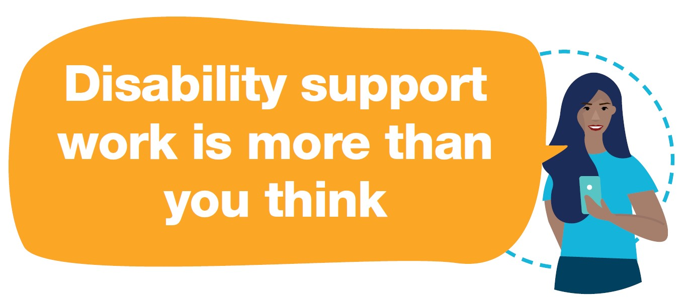

Opportunity Awaits ... By 2023
1 in 5 new jobs in Australia will be in the disability sector
In WA, an estimated 10,000 new disability sector jobs will be created
Career opportunities include support workers, occupational therapists, speech pathologists, physiotherapists and support coordination jobs

1. About You
- Great communication skills
- Positive attitude
- Work well with others
- Punctual and reliable
- Problem-solver and flexible
The disability sector is looking for people like you!

2. What To Expect
- Every day is different
- More than a salary – personal and professional growth
- Career progression opportunities
- Full-time, part-time and casual employment options
- Disability Support Worker base rates range between $21.57 and $43.14 (penalty rates and allowances apply)

3. Get Job-ready
- Current driver’s licence
- Current First Aid Certificate
- NDIS Quality, Safety & You Certificate – free at
Worker Orientation Module ‘Quality, Safety and You’ (90 minutes to complete)
- Certificate III in Individual Support (Disability) is highly regarded but not essential

4. Interested?
Discover more www.thinksupport.org.au
Register for a job www.jobsinwadisabilityservices.com
Make a call enquire with local disability service providers
Explore training options www.jobsandskills.wa.gov.au and www.apprenticeshipcommunity.com.au

