Your Skills
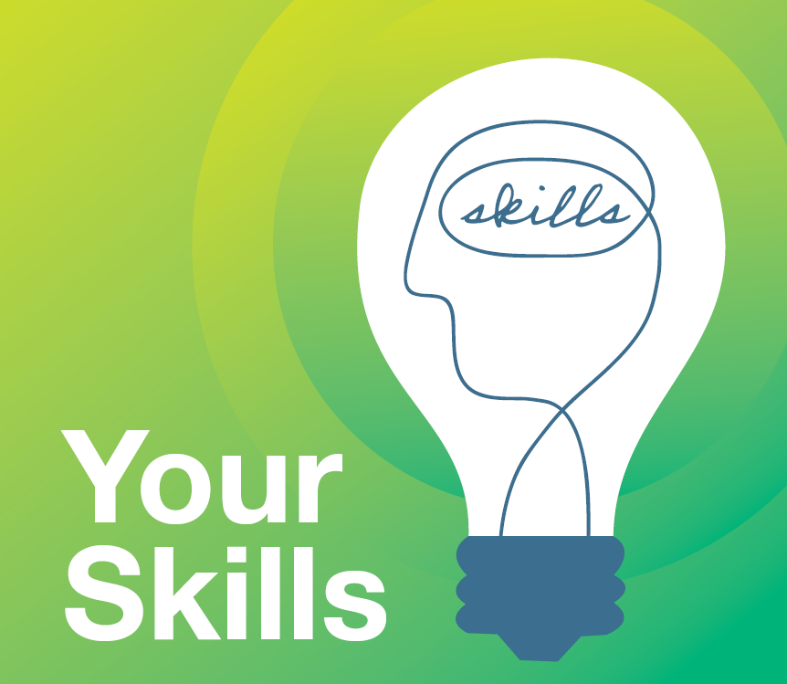
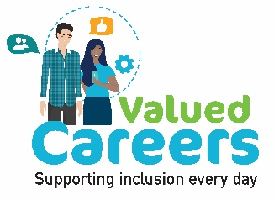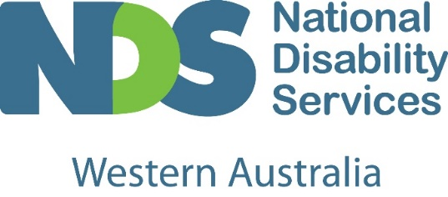
Think about the skills and values you have, and how they can shape your career in the disability sector.

Your transferable skills and personal values could make you a perfect candidate to work in the disability sector.

Transferable Skills:
Transferable skills are abilities you have developed throughout your life. These can include things like communication, team work and creativity. They are helpful every day in different areas of your life: socially, professionally and at school.
Many transferable skills are highly valued by employers in the disability and allied health sectors. Identifying and providing examples of the skills that you have developed will help show employers that you are the right person for the job.

Values Based Employment:
Your values, motivation and attitudes shape you as a person and the way you approach activities, including work. Values based employment involves selecting candidates whose own attitudes, values and behaviours align with those of the organisation and the requirements of the job.
The disability sector focuses on a person-centred approach, where an individual’s needs, wants and goals are the primary consideration. An individualised support plan is then developed for that person.
By focusing on your values first and qualifications second, employers can be more comfortable that you will support their person-centred approach.
Whilst some roles require formal qualifications, you may already have the foundation skills and values to start your career in the disability sector.

Your Skills: Disability Support Worker
Problem solving: The different circumstances of each individual provides ample opportunity to demonstrate your problem solving capabilities. You think outside the box, find creative solutions and positive outcomes for every person with disability you support.
Adaptable: Every individual is unique and every day can be different. Your flexibility allows you to adapt to each situation, customising solutions that best fit an individual’s immediate requirements.
Empathetic: Your genuinely caring and empathetic nature helps you excel in a disability support worker role where you focus on the wellbeing and goals of the individual and their lives.
Communication: Your solid communication and interpersonal skills are invaluable for successful disability support work. You understand, interpret and relate well with the people you support and your team members and colleagues. Everyone has the right to make decisions about the things which affect them. You will utilise your clear communication skills to support people with disability, where needed, to make their own decisions.
Confidence: Your motivation and self-esteem makes you a natural fit as a disability support worker. You bring an energetic, encouraging and confident attitude to the role, supporting people with disability to live a life of their choosing.

Your Skills: Occupational Therapist
Empathetic: With your support individuals with a disability will focus on achieving increasing independence. Your calm, pragmatic and empathetic nature helps you provide quality support throughout the journey.
Creativity: Creativity isn’t something that can always be taught, but is often a part of who we are. Your ability to assess a situation and propose innovative ways of doing things can be the basis of a unique and practical therapy plan for the individuals you support.
Optimism: Your optimism, upbeat and positive outlook is a wonderful trait to have and an important part of a person’s progress. Therapy may sometimes be a long process and your positive strengths-based approach will assist you to support people with disability in this role.
Team player: Your strong interpersonal and collaboration skills, along with your flexibility help you to connect and relate to a variety of people, reassuring them of your professional and empathetic approach.

Your Skills: Education Assistant
Team player: Your strong interpersonal and collaboration skills, along with your flexibility help you to connect and relate to a variety of people. As an Education Assistant working as part of an educational team, you foster relationships and develop strong communication skills which enable you to work effectively together, resulting in positive learning experiences for your students.
Multitasker: Your ability to effortlessly do multiple things at once or switch between different activities or tasks with ease are a great skill for an Education Assistant to have. A typical day may include supporting several students to engage in a range of classroom activities, so your ability to multitask will give you an edge.
Tech savvy: Technology is now part of our everyday life having changed the way we work, live and learn. Your tech knowledge is invaluable as an Education Assistant, providing an array of engaging, fun options in assisting students to learn and grow.
Communication: Your friendly communication and interpersonal skills are invaluable to support students. Many of your students have diverse learning needs and your ability to communicate clearly and in an encouraging manner fosters a supportive and inclusive learning environment. You’re able to help students achieve their goals and learn in a positive and rewarding way.

Your Skills: Speech Pathologist
Empathetic: Your sincere desire to help and caring and empathetic nature are qualities that ensure you can connect with individuals to effectively manage a wide range of speech and communication issues.
Creativity: No two people are the same and so your improvisation, creativity and adaptability are wonderful skills that allow you to recognise and create personalised plans for each individual’s immediate needs and goals.
Good listener: Your active listening skills help you to connect and understand the needs and wants of the individual and their family, so that you can work together to meet their therapy goals.
Communication: Your strong oral and written communication skills are essential to support people with disability, and it also means you can effectively collaborate with a variety of other practitioners, support workers and family for the greater benefit of the individual.
Problem solving: Your problem solving skills and creative thinking are important attributes because not every challenge has just one solution. Capitalising on your problem solving capabilities allows you to think outside the box and navigate the different therapies and strategies that work best for each person.

nds.org.au
National Disability Services is Australia’s peak representative body for non-government disability service providers.

